Tyria

Rago`s Flame Staff

Boss Rago Kindlerock
Lokacija Sorrow's Furnace
Kontinent Deldrimor War Camp

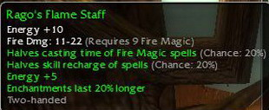

Energy +10
Fire damage: 11-22 (req. 9 Fire Magic)
Halves casting time of Fire Magic spells (Chance: 20%)
Halves skill recharge of spells (Chance: 20%)
Energy +5
Enchantments last 20% longer

Brzi Gonzales

