Zelena oruzja u Factions za Rangera st.1
Shing Jea Island
Ahvha's Longbow
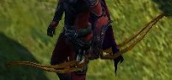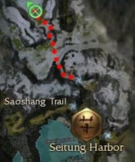
Jin's Hornbow
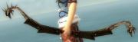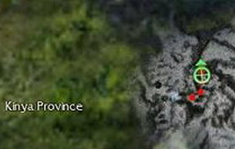
Kaineng City
Kaolin Longbow
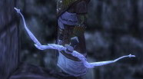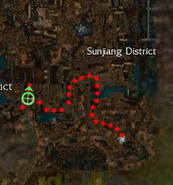
Royen's Hornbow
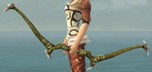
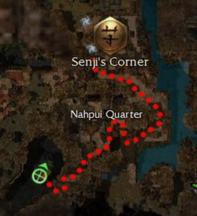
Pongmei Valley
Meynsang's Longbow
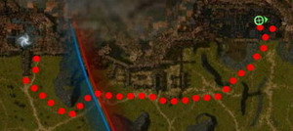
Echovald Forest
Chkkr's Flatbow
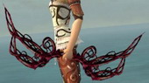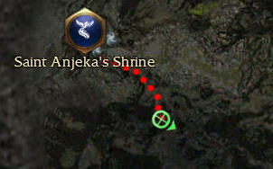
Inallay's Hornbow
